The Horizon Storyline
The Horizon Storyline is a tool developed in the book God Dreams by Will Mancini that ‘snaps’ into the Vision Frame as the most complete visionary picture of your church. It’s a visionary planning tool designed to provide the right amount of vision content at the right amount of time in the future for the entire leadership team. The Horizon Storyline, or 1:4:1:4, equates how we physically see with a Foreground, Midground, Background, and Beyond-The-Horizon and translates that into time frames for the church’s vision:

  - Beyond-the-horizon vision: A 5-20 year picture of your church’s future and ultimate contribution to the Kingdom of God.

  - Background vision: Identifies four 3-year goals you need to achieve in order to accomplish the 5-20 year vision.

  - Midground vision: Identifies the sole important emphasis/goal for the coming year.

  - Foreground vision: Determine four initiatives to be completed in the next 90-days to take the first steps in achieving your vision.

*The Foreground Vision has a 90-Day time stamp. Nexus’ preference is for this to be a 120-Day (4 month) time frame in line with the annual ministry seasons. [Christmas to Easter - Easter to Fall - Fall to Christmas]

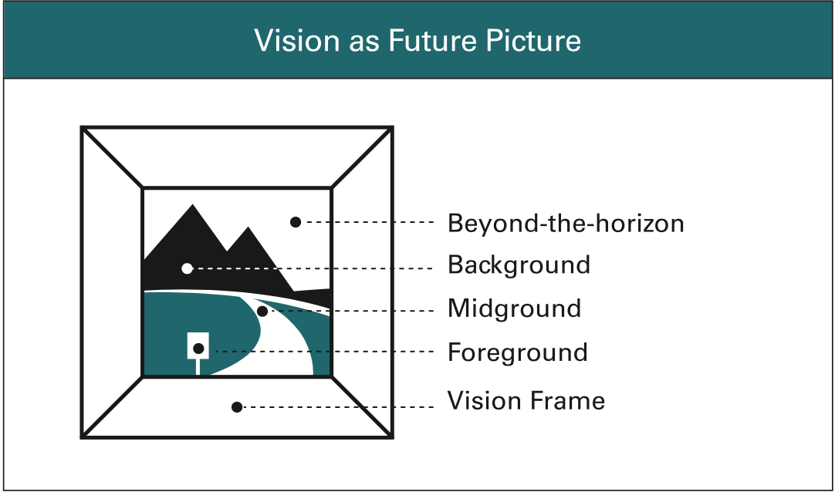
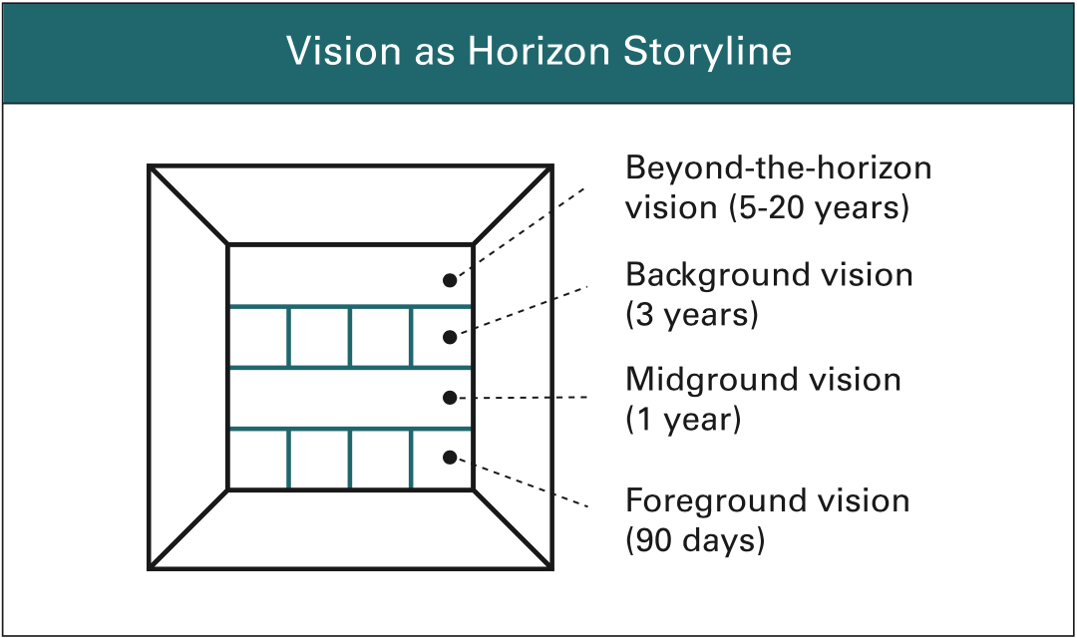

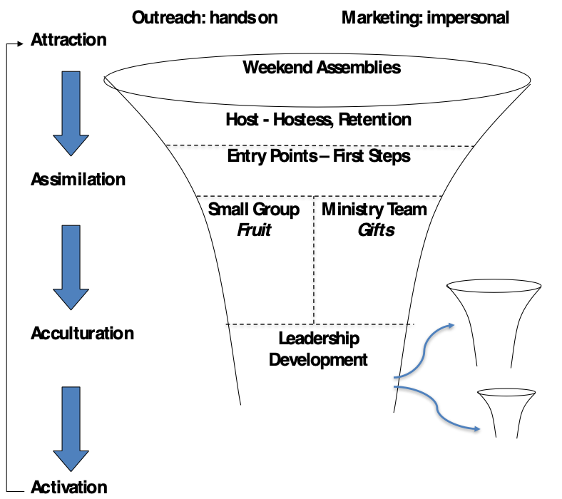
Strategic Evaluation: Seeing Your Big Picture:
Attraction
Connecting with Lost People In Our Community

Assimilation
Connecting New People into Our Faith Community

Acculturation
Connecting New People with values, beliefs, and story

Activation
Connecting Our People with God’s Mission

Multiplying
Are you showing signs of “pregnancy” by multiplying disciples, leaders, small groups, and churches?

Evaluate how you’re doing in each area using the Four Helpful Lists.
There are five things Churches must do well
5 Things | What’s Working?  (Celebrate) | What’s Broken?  (Obstacles) | What’s Confused?  (Clarify) | What’s Missing?  (Needs)
Attraction
(Outreach/Marketing)
Assimilation
(Retention/
First Steps)
Acculturation
(Groups/
Ministry Teams)
Activation
(Leadership Development)
Multiplication
(Multiplying Disciples)

Strategic Planning:
Considering your strategic evaluation, What’s Important Now? Planning for the 3 Church Seasons
- Jan-Easter ☐ Easter-Summer ☐ Fall-Christmas

Foreground Vision (120 days)
Taken from the Horizon Storyline part of the Vision Frame, the foreground vision contains up to four specific initiatives that must be started within 120 days, as needed. Think of these as the four most important next steps in the life of the church. It answers the question, “Four months from now, what will we be glad we started working on four months ago?”
Foreground Initiatives
1) | 2) | 3) | 4)
Action Steps

  - Clarifies weekly action steps and daily priorities for leaders.
  - Sequences short-term projects, tasks, and goals.
  - Activates the unique gifts and abilities within the body.
  - Provides regular, positive accountability for individuals and teams.

